_________________________________________________
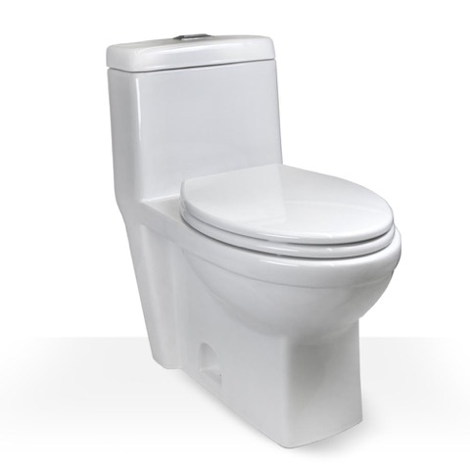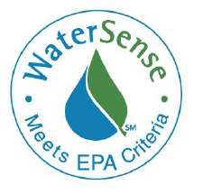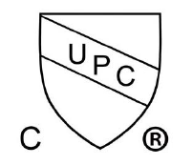

Specifications:
Material: Grade A Vitreous China
Color: White
Rough In: 12”
Water Use: 4.8LPF / 1.8LPF
Flush System: Siphon Action
Water Surface: 8” x 6”

Finish: Glossy
Conception: One Piece Skirted
Bowl Height: 16.5”
Bowl Type: Elongated
Trap Way: 2 1/8”
Gross Weight: 103lbs

